Protech Trading Inc.

Norstar Modular 616 Telephone System

Time and Date programming

Programming has to be done from M7310 or M7324 Display Telephone
The following keys are used for programming:
Feature, Rls, Dial Pad keys, and keys signed as
Heading, Back, Show, Next on the picture below.

Example:
Display shows Press
-------------------------------------------------------------------------------------------------
May 12 9 : 21 am Start to programming Feature * * 2 3 6 4 6

-------------------------------------------------------------------------------------------------
Password: 2 3 6 4 6
RETRY
------------------------------------------------------------------------------------------------
1. Sys speed dial Next (Last No.)

------------------------------------------------------------------------------------------------
2. Names Next (Last No.)

------------------------------------------------------------------------------------------------
3. Time and date Show (Conf / Transf)

------------------------------------------------------------------------------------------------
3. Time 9 : 21 ( if you want to change, press CHANGE (Soft Key),
CHANGE if not, press Next (Last No.)
------------------------------------------------------------------------------------------------
Hour: 09 ( if you want to change, press CHANGE (Soft Key),
CHANGE CHANGE (Soft Key)
------------------------------------------------------------------------------------------------
Hour: enter hour (2 digits) using dial pad and press
Next (Last No.)
------------------------------------------------------------------------------------------------
Minutes: 21 ( if you want to change, press CHANGE (Soft Key),
CHANGE if not, press Next (Last No.)
------------------------------------------------------------------------------------------------
Minutes: enter minutes (2 digits) using dial pad and press
Next (Last No.)
------------------------------------------------------------------------------------------------
AM if change is needed, press CHANGE (Soft Key),
CHANGE if not, press Next (Last No.)
------------------------------------------------------------------------------------------------
Date: 12 May 04 ( if you want to change, press CHANGE (Soft Key),
CHANGE if not, press Next (Last No.)
------------------------------------------------------------------------------------------------

Protech Trading Inc.

------------------------------------------------------------------------------------------------
Year: 04 ( if you want to change, press CHANGE (Soft Key),
CHANGE if not, press Next (Last No.)
------------------------------------------------------------------------------------------------
Year: enter year ( 2 digits) using dial pad and press
Next (Last No.)
------------------------------------------------------------------------------------------------
Month: 05 ( if you want to change, press CHANGE (Soft Key),
CHANGE if not, press Next (Last No.)
------------------------------------------------------------------------------------------------
Month: enter month ( 2 digits) using dial pad and press
Next (Last No.)
------------------------------------------------------------------------------------------------
Day: 12 ( if you want to change, press CHANGE (Soft Key),
CHANGE if not, press Next (Last No.)
------------------------------------------------------------------------------------------------
Day: enter day ( 2 digits) using dial pad and press
Next (Last No.)
------------------------------------------------------------------------------------------------
4. Direct - Dial RLS
------------------------------------------------------------------------------------------------

End of Time and Date programming

==========================================================================
The same programming sequence written in different way :

press Feature * * 2 3 6 4 6
“Password:” - press 2 3 6 4 6
“ 1. Sys speed dial” – press NEXT
“ 2. Names” – press NEXT
“3. Time and date” – press SHOW
“Time xx:yy” – press CHANGE
“Hour: xx” – press CHANGE
“Hour:” – enter hour using dial pad – press NEXT
“Minutes: yy” – press CHANGE
“Minutes:” – enter minutes using dial pad
“AM” – press CHANGE for PM if needed – press NEXT
“Date xx yy zz” - press CHANGE
“Year: zz” – press CHANGE
“Year:” – enter 2-digit year using dial pad – press NEXT
“Month: yy” – press CHANGE
“Month:” – enter month (01-12) using dial pad – press NEXT
“Day: xx” – press CHANGE
“Day:” – enter day (01-31) using dial pad – press NEXT
“ 4. Direct -Dial” – press RLS

Page 2

Protech Trading Inc.
773-205-2191

M7310 Telephone Programming Buttons

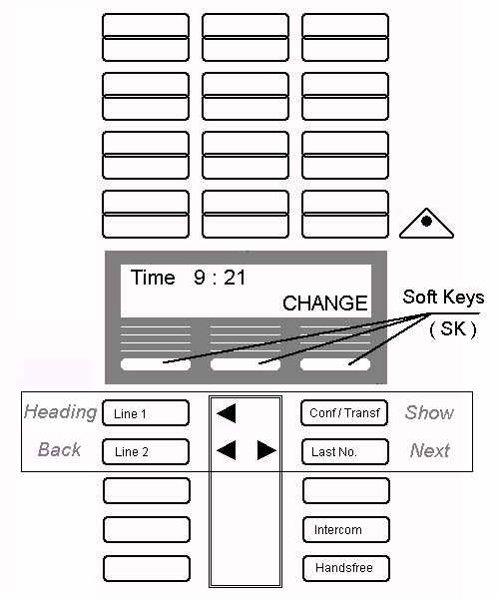

Page 3

